Handles activities that normally considered to be operating system responsibilities, such as thread management (scheduling), synchronization primitives, deadlock detection, and memory management, including buffer pool.
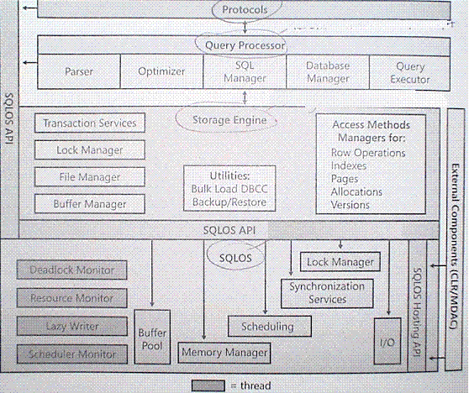

Each instance of SQL Server is a separate operating system process. Each instance must handle potentially thousands of concurrent requests from users. Instances of SQL Server use Microsoft Windows threads, or if configured, they use fibers, to manage these concurrent tasks efficiently. Each instance of SQL Server always runs several threads for system processes.
Each instance of SQL Server has an internal layer that implements an environment similar to an operating system. This internal layer is used for scheduling and synchronizing concurrent tasks without having to call the Windows kernel. This internal layer can also schedule fibers or Windows threads effectively. Each instance of SQL Server maintains a pool of either Windows threads or fibers for processing user queries.
To understand how a request or a task is processed, it is helpful to understand the following basic terms:
Connection
A connection is established when the user is successfully logged in. The user can then submit one or more Transact-SQL statements for execution. A connection is closed when the user explicitly logs out, or the connection is terminated.

Batch
An SQL batch is a set of one or more Transact-SQL statements sent from a client to an instance of SQL Server for execution. It represents a unit of work submitted to the Database Engine by users.

Task
A task represents a unit of work that is scheduled by SQL Server. A batch can map to one or more tasks. For example, a parallel query will be executed by multiple tasks.
Windows thread
Each Windows thread represents an independent execution mechanism.
fiber
A fiber is a lightweight thread that requires fewer resources than a Windows thread and can switch context when in user mode. One Windows thread can be mapped to many fibers.
worker thread
The worker thread represents a logical thread in SQL Server that is internally mapped (1:1) to either a Windows thread or, if lightweight pooling is turned ON, to a fiber. The mapping is maintained until the worker thread is deallocated either because of memory pressure, or if it has been idle for a long time. The association of a task to a worker thread is maintained for the life of the task.

While threads and fibers are lightweight in their use of resources, they still consume resources. In systems with hundreds or thousands of user connections, having one worker thread per connection can consume enough resources to reduce the efficiency of SQL Server. Additionally, allocating a dedicated worker for each user connection is not required, because most connections actually spend much of their time waiting for batches to be received from the client. Instead, the instance of SQL Server uses a pool of worker threads. The pool of worker threads only has to be large enough to service the number of user connections that are executing batches at the same time in that instance. Leaving the max worker threads option at its default value of 0 allows the instance of SQL Server to effectively map user connections over several worker threads. This ensures that they do not consume too many resources.

When an application connects to the Database Engine, it is assigned a session ID (SPID). All information that must be maintained for the life of the connection is managed in internal data structures associated with the SPID. As an instance of SQL Server receives batches from clients, it breaks the batch into one or more tasks and then associates each task with an available worker thread from a pool of worker threads. A worker thread is bound to the task for the lifetime of the task. A worker thread runs the request on the associated SQL scheduler. If there are no free worker threads and the max worker threads value has not been reached, the instance of SQL Server allocates a new worker thread for the new batch. If there are no free threads or fibers available and the max worker threads value has already been reached, the instance of SQL Server blocks the new task until a worker thread is freed.
After a worker is associated with a task, it remains associated with the task until it is completed, for example, until the last of the result sets generated by the batch has been returned to the client. At that time, the worker thread is freed and can be paired with the tasks associated with the next batch.

The following table shows the automatically configured number of max worker threads for various combinations of CPUs and versions of SQL Server.
Number of CPUs 32-bit computer 64-bit computer
<= 4 processors 256 512
8 processors 288 576
16 processors 352 704
32 processors 480 960
Note:
We recommend 1024 as the maximum for 32-bit SQL Server and 2048 for 64-bit SQL Server.

The general rule I know is: 1 data file per logical or physical processor (i.e. a SQL Server 2005 running on 4 quad-core cpus -> 16 cores should have 16 data files for TempDB)

-- Get Avg Task Count and Avg Runnable Task Count
SELECT AVG(current_tasks_count) AS [Avg Task Count],
AVG(runnable_tasks_count) AS [Avg Runnable Task Count]
FROM sys.dm_os_schedulers WITH (NOLOCK)
WHERE scheduler_id < 255;

-- Get Log reuse wait description
SELECT [name], log_reuse_wait_desc
FROM sys.databases WITH (NOLOCK)
WHERE database_id > 4;

-- Find out how many full-text changes are pending on a table
SELECT OBJECTPROPERTY(OBJECT_ID('CurrentPostFullTextMonday'),
'TableFulltextPendingChanges') AS 'Monday Full Text Pending Changes';

-- Find oldest open transaction
DBCC OPENTRAN

-- Find command for a given SPID
DBCC INPUTBUFFER(290)

-- Kill a SPID
KILL 290

